

Tribhuvan University
Faculty of Humanities and Social Science

A PROJECT REPORT
ON
GROCERY DELIVERY SYSTEM

Submitted to:
Department of Computer Application
Ed-Mark College

In partial fulfillment of the requirements for the Bachelors in Computer Application

Submitted by:
Goma Garanja Magar
[TU Reg No: 6-2-727-13-2022]

Under the Supervision of
Mr. Shyam Maharjan

February, 2026

Tribhuvan University
Faculty of Humanities and Social Sciences
Ed-Mark College

SUPERVISOR’S RECOMMENDATION
I hereby recommend that this project prepared under my supervision by Goma Garanja Magar entitled “Grocery Delivery System” in partial fulfillment of the requirements for the degree of Computer Application is recommended for the final evaluation.

Project Supervisor
Mr. Shyam Maharjan
Department of Bachelor in Computer Application Ed-Mark College
Kalanki, Kathmandu


Tribhuvan University
Faculty of Humanities and Social Science
Ed-Mark College

LETTER OF APPROVAL
This is to certify that this project is prepared by Goma Garanaja Magar entitled “Grocery Delivery System” in partial fulfillment of the requirements for the degree of Bachelor in Computer Application has been evaluated. In our opinion it is satisfactory in the scope and quality as a project for the required degree.

-------------------------------------------  Mr. Shyam Maharjan  Supervisor  Department of bachelors in  Computer Application  Ed-Mark College  Kalanki, Kathmandu | --------------------------------------------  Er. Sanjay Kumar Sah  Co-Ordinator  Department of bachelors in  Computer Application  Ed-Mark College  Kalanki, Kathmandu
-------------------------------------------  Internal Examiner | --------------------------------------------  External Examiner

ABSTRACT
The Grocery Delivery System is designed to provide customers with a convenient, efficient, and reliable platform for purchasing groceries online. The system allows users to browse a wide range of grocery items, add them to a virtual cart, and place orders from the comfort of their homes. It eliminates the need for physical visits to stores by ensuring doorstep delivery within a specified time frame. The system incorporates features such as user authentication, product search and filtering, secure payment integration, and order tracking to enhance the overall shopping experience. On the backend, it provides store administrators with tools to manage inventory, update product details, and process orders effectively. By combining modern web technologies and database management, the system aims to reduce time, improve customer satisfaction, and streamline the traditional grocery shopping process into a digital solution.
Keywords: Grocery Delivery, Online Shopping, E-commerce, Inventory Management, Order Tracking.

ACKNOWLEDGEMENT
It is with great pleasure that I present this project report on "Grocery Delivery System". The successful completion of this work would not have been possible without the guidance, encouragement, and support of several individuals and institutions, to whom I express my heartfelt gratitude.
First and foremost, I extend my sincere appreciation to Tribhuvan University for providing me with the opportunity to undertake this project. I owe a special debt of gratitude to my Project Supervisor Mr. Shyam Maharjan and Program Coordinator Er. Sanjay Kumar Sah, whose invaluable guidance, insightful advice, and unwavering support were instrumental in shaping this project. Their mentorship has been truly inspiring.
I am also deeply grateful to Ed-Mark College and my esteemed Principal Mr. Shiva Prasad Adhikari, for fostering an environment that nurtures academic excellence and personal growth.
I also extend my appreciation to my teammates for their dedication, collaboration, and perseverance, which made this endeavor possible. A heartfelt thank you to my seniors for their valuable insights and to my friends for their constant encouragement and assistance throughout this journey.
Lastly, I am profoundly grateful to my families for their unwavering support, motivation, and belief in me. Their encouragement has been my greatest source of strength.
I hope this report meets the academic standards and serves as a meaningful contribution to our field of study.
Thank you all for being a part of this incredible journey.
Sincerely,
Goma Garanja Magar
[Reg. No: 6-2-727-13-2022]
6th Semester
Table of Contents

SUPERVISOR’S RECOMMENDATION i
LETTER OF APPROVAL ii
ABSTRACT iii
ACKNOWLEDGEMENT iv
LIST OF FIGURES viii
LIST OF TABLES ix
CHAPTER 1: INTRODUCTION 1
1.1. Introduction 1
1.2. Problem Statement 1
1.3. Objectives 2
1.4. Scope and Limitations 3
1.5. Report Organization 4
CHAPTER 2: BACKGROUND STUDY AND LITERATURE REVIEW 5
2.1. Background Study 5
2.2 Study of existing System 5
2.2. Literature Review 7
3.1. System Analysis 9
3.1.1. Requirement Analysis 9
3.1.2. Feasibility Study 12
3.1.3. Data Modeling 13
3.1.4. Process Modeling 14
3.2. System Design 15
3.2.1. Architectural Design 16
3.2.2. Database Schema Design 17
3.2.3. Interface Design 17
3.3 High -Level Design 18
3.3.1 Methodology of the system 18
3.3.2 Algorithm Details 19
CHAPTER 4: IMPLEMENTATION AND TESTING 24
4.1 Implementation 24
4.2 Implementation Details of Modules 26
4.3. Testing 37
4.3.1. Test Case for Unit Testing 37
4.4 Test Cases for System Testing 39
CHAPTER 5: CONCLUSION AND RECOMMENDATION 41
5.1. Lessons Learned / Outcomes 41
5.2. Conclusion 41
5.3. Future Recommendation 42
REFERENCE
APPENDICES

LIST OF ABBREVIATIONS

CASE Computer Aided Software Engineering
CSS Cascading Style Sheet
DFD Data Flow Diagram
ER Entity Relationship Diagram
HTML Hyper Text Markup Language
Js JavaScript
UI User Interface
NFRs Non-Functional Requirements
FRs Functional Requirements

LIST OF FIGURES
Fig 1: Use Case Diagram of Grocery Delivery System……………………………………….10
Fig 1.1: Gantt Chart of Grocery Delivery System…………………………………………….12
Fig 1.2: ER-Diagram of Grocery Delivery System………………………………………...…13
Fig 1.3: 0 level DFD of Grocery Delivery System……………………………………………14
Fig 1.4: Level 1 DFD of Grocery Delivery System………………………………..................15
Fig 1.5: Architectural design of Grocery Delivery System……………………………………16
Fig 1.6: Database Schema Design of Grocery Delivery System…………………..................17
Fig 2: Home Page of Grocery Delivery System………………………………………………17
Fig 2.1: Sign in page of Grocery Delivery System……………………………………………18
Fig 2.2: Admin Dashboard of Grocery Delivery System………………….............................18
Fig 2.3: Agile Software Development Model for GDS………………………….……………19
Fig 2.4: Module Implementation of Grocery Delivery System………………………………24

LIST OF TABLES

Table 1: Gantt Chart of Grocery Delivery System……………………..……………………...13
Table 2: User Registration Testing of GDS…………………………………….……………..35
Table 3: User Login Testing of GDS……………………………………...………..………....36
Table 4: Admin Registration Testing of GDS…………………………..……………..……...36
Table 5: Admin Login Testing of GDS………………………………………………………..37
Table 6: Product Adding Testing of GDS…………………………………………………….37
Table 7: Category Adding Testing of GDS…………………………………………..………..37
Table 8: System Testing of Grocery Delivery System ………………………………….……28

CHAPTER 1: INTRODUCTION

1.1. Introduction
A Grocery Delivery System is a web-based application designed to simplify the process of ordering and delivering grocery items online. In this project, the system is developed using HTML, CSS, JavaScript for the frontend to provide a dynamic, responsive, and user-friendly interface, and PHP with a backend server and MySQL database to manage data processing, authentication, order handling, and secure storage.
The system provides a centralized platform where customers and admin can interact efficiently. Customers can register and log in securely, browse available grocery products, search and filter items by category, add products to their cart, place orders, and track delivery status in real time. The admin is responsible for managing users (customers), products, orders, and overall system operations.
The Grocery Delivery System supports both scheduled deliveries and instant deliveries, offering flexibility and convenience to customers. Key features include secure user authentication, role-based access control, product and inventory management, order and payment processing. By automating ordering, inventory management, and delivery coordination, the system reduces manual effort, enhances operational efficiency, and provides a fast, reliable, and convenient shopping experience for users.

1.2. Problem Statement
In traditional grocery shopping systems, customers are required to physically visit stores to purchase daily essentials. This process can be time-consuming, inconvenient, and inefficient, especially for working individuals, elderly people, and those living far from markets. Long queues, limited store hours, and product unavailability further reduce customer satisfaction.
Store owners also face challenges in managing inventory, handling orders, updating prices, and coordinating deliveries manually. Without a proper digital system, errors in billing, stock mismanagement, and delayed deliveries are common. Communication between customers, store staff, and delivery personnel is often unorganized, leading to confusion and inefficiency.
Therefore, there is a need for a Grocery Delivery System that provides a centralized digital platform to simplify online ordering, inventory management, secure payments, and delivery tracking.
The main problems identified in the existing system are as follows:
- Time-Consuming Shopping Process
Customers must physically travel to stores, which may involve traffic congestion, long queues, and limited billing counters. This makes grocery shopping inconvenient, particularly during busy schedules.
- Lack of Online Ordering Facility
Many small and medium grocery stores do not provide online platforms for browsing and ordering products. Customers cannot check product availability or prices before visiting the store.
- Inefficient Inventory Management
Manual stock management can lead to inaccurate product availability information. Sometimes customers find that items are out of stock only after reaching the store.
- Poor Order and Delivery Management
Traditional systems do not provide proper order tracking or delivery updates. Customers remain unaware of delivery status, leading to confusion and dissatisfaction.
- Lack of Personalized Recommendations
Physical stores cannot easily analyze customer purchasing patterns. Without a recommendation system, customers may miss relevant products, and businesses lose opportunities for increased sales.
- Security and Payment Issues
Cash-based transactions dominate traditional grocery shopping. This increases risks such as loss of money, lack of transaction records, and limited payment flexibility.

1.3. Objectives
- To allow customers to browse and search products and categories.
- To implement cart and checkout functionality.
- To provide admin control for product and user management.
- To implement a recommendation algorithm for suggesting relevant products.

1.4. Scope and Limitations
1.4.1. Scope
The scope defines the boundaries and coverage of the proposed system. The Grocery Delivery System (GDS) is designed to provide an online platform that connects customers and grocery stores efficiently. The scope of the system includes the following:

- Online User Registration and Authentication
The system allows users to create accounts, log in securely, and manage their profiles. Authentication ensures that only registered users can place orders and access personalized features.
- Product Browsing and Search
Customers can view available grocery items categorized into different sections such as fruits, vegetables, dairy, beverages, and household products. A search feature enables users to quickly find specific products.
- Shopping Cart Management
Users can add items to a shopping cart, update quantities, remove products, and view the total price before checkout. This allows flexible and convenient order preparation.
- Online Order Placement
The system enables customers to place orders online without visiting the store physically. Customers can confirm delivery details and complete the checkout process smoothly.
- Payment Integration
The system supports online payment methods such as E-Sewa, Khalti, debit/credit cards, or cash on delivery. This provides flexibility and secure transaction processing.
- Admin Management Panel
The admin can add, update, or delete products, Manage categories, View and manage orders, Monitor users, Update stock availability. This ensures proper system control and inventory management.

- Recommendation System
The system provides basic product recommendations based on user purchase history or frequently bought items. This enhances user experience and increases sales opportunities.
1.4.2 Limitations
- The system may not handle very large-scale operations like national supermarket chains without additional scaling.
- Delivery is limited by geographic coverage; only areas supported by the store will receive orders.
- The system cannot control external factors like traffic delays, weather conditions, or third-party delivery issues.
- Payment depends on online payment gateways or cash on delivery, which may have transaction limitations.

1.5. Report Organization
This report is organized into 5 chapters:
Chapter 1 - Introduction: This chapter introduces the problem statement, objectives and limitations of the project.
Chapter 2 - Requirement and Feasibility Analysis: This chapter describes about the functional and non-functional requirements, economic feasibility, technical feasibility, operational feasibility and scheduling feasibility.
Chapter 3 - System Design: This chapter introduces about the system and interface design of the project app.
Chapter 4 - Implementation and Testing: This chapter clearly illustrates the methods and tools used to implement the project.
Chapter 5 - Conclusion and Future Works: This is the final chapter that concludes the project and talks about our future plans with the project.

CHAPTER 2: BACKGROUND STUDY AND LITERATURE REVIEW

2.1. Background Study
A Grocery Delivery System plays a vital role in modernizing the shopping experience by providing a structured digital platform for purchasing and delivering daily essentials. It allows customers to browse products, add items to a cart, place orders, make online payments, and track deliveries in real time. Similarly, it enables store managers to organize products, manage inventory, process orders, and monitor sales efficiently. However, handling product listings, customer data, inventory records, and delivery operations can be challenging without a streamlined digital system.[1]
Store owners often rely on manual methods, phone calls, or messaging apps to receive and confirm orders, which can lead to delays, miscommunication, and order errors. Maintaining accurate stock records and updating product availability manually can result in shortages or overstocking. Coordinating deliveries and assigning delivery personnel without a centralized system may create confusion and inefficient routing. Additionally, generating reports on sales performance, customer preferences, and inventory trends becomes difficult without proper analytical tools.[3]
The proposed Grocery Delivery System aims to address these challenges by providing a centralized platform to manage products, customers, orders, payments, and deliveries efficiently. It simplifies product management, enhances communication through notifications and status updates, enables secure online transactions, and generates reports and analytics to support better business decisions.[5]

2.2 Study of existing System
Instacart
Instacart is a popular online grocery delivery platform that connects customers with local supermarkets and stores. It allows users to browse products, place orders, schedule deliveries, and track orders in real time. The platform provides features such as secure payment options, product search, and personalized recommendations. However, Instacart charges delivery fees and service fees, which may increase overall costs for customers. Additionally, it depends heavily on third-party stores, which may result in inconsistent pricing and product availability.[1]
Amazon Fresh
Amazon Fresh is an online grocery delivery and pickup service offered by Amazon. It provides a wide range of grocery products, fast delivery options, and integration with Amazon accounts for seamless shopping. The system offers advanced features such as real-time order tracking, digital payments, and customer reviews. Despite its efficiency and reliability, Amazon Fresh is available only in selected locations and often requires a subscription (such as Amazon Prime), which may not be affordable for all users.[2]
Walmart Grocery
Walmart Grocery allows customers to order groceries online for home delivery or store pickup. It offers competitive pricing, a large product catalog, and flexible delivery scheduling. The system is well-integrated with Walmart’s physical stores, ensuring better inventory synchronization. However, delivery availability may vary depending on location, and during peak times, delivery slots may become limited.[3]
BigBasket
BigBasket is a leading online grocery delivery platform in India. It provides doorstep delivery, subscription-based services for regular items, and multiple payment options. The system offers category-based browsing and frequent discounts to attract customers. However, service coverage is limited to specific cities, and delivery delays may occur during high-demand periods.[4]
FreshDirect
FreshDirect is an online grocery shopping service that focuses on delivering fresh produce, dairy, and household items directly to customers. It emphasizes quality control and scheduled delivery services. While it provides a reliable shopping experience, it operates in limited geographic areas and may have higher pricing compared to local stores.[5]

2.2. Literature Review
The rapid growth of e-commerce has significantly transformed the retail industry, particularly in the grocery sector. According to a report by McKinsey & Company, online grocery adoption has accelerated due to digital transformation and evolving consumer behavior. The report highlights that convenience, time-saving benefits, and improved delivery logistics are major factors driving customers toward online grocery platforms. However, long-term sustainability depends on operational efficiency, integrated supply chain management, and customer retention strategies rather than short-term sales growth. This indicates that a Grocery Delivery System must incorporate performance monitoring mechanisms and scalable architecture to ensure sustainable operation.[1]
Usability is a critical determinant of customer engagement in digital platforms. Jakob Nielsen emphasized that intuitive design, minimal cognitive load, and structured navigation significantly enhance user satisfaction and reduce abandonment rates. In grocery delivery systems, users expect efficient product search, smooth cart management, secure payment processing, and transparent pricing. Poor interface design can increase cart abandonment and reduce trust. Therefore, user-centered design principles must be integrated into the development of the proposed system to enhance overall effectiveness.[2]
Comparative analyses of leading e-commerce platforms such as Amazon and Walmart reveal that logistics integration, real-time inventory visibility, and last-mile delivery optimization directly influence customer satisfaction and competitive performance. Studies published in retail management research indicate that features such as real-time order tracking, accurate stock updates, and flexible delivery scheduling improve reliability and user experience. These findings justify the inclusion of integrated inventory management and delivery tracking modules in the proposed Grocery Delivery System.[3]
System performance and scalability are also essential factors in digital commerce success. Laudon and Traver emphasize that e-commerce systems must maintain high availability, fast response times, and secure transaction processing to sustain user trust and business continuity. Technical inefficiencies, slow system performance, or security vulnerabilities may directly impact customer loyalty and organizational reputation. Therefore, defining strong non-functional requirements—such as scalability, performance optimization, and data security—is crucial for the Grocery Delivery System.[4]
Mobile commerce has further reshaped consumer purchasing behavior. Reports by Statista indicate that a significant proportion of online grocery purchases are conducted via smartphones. Research suggests that mobile responsiveness alone is insufficient; systems must be optimized for low-bandwidth environments, cross-device compatibility, and efficient mobile navigation. In developing contexts, mobile-friendly systems are particularly important due to connectivity limitations. Hence, the proposed Grocery Delivery System must prioritize responsive and lightweight design to ensure accessibility and inclusivity.[5]

CHAPTER 3: SYSTEM ANALYSIS AND DESIGN

3.1. System Analysis
System analysis is a critical phase in the software development lifecycle, focusing on understanding, defining, and modeling the requirements of a system to be developed or improved. The purpose of the System Analysis is to establish a comprehensive Grocery Delivery System (GDS) that facilitates effective interaction between admins, and customers. The system is designed to provide a centralized digital platform where grocery items can be listed, ordered, and delivered efficiently.
The platform features a dynamic interface where customers can browse available products, place orders, schedule deliveries, and make payments online. Vendors can manage product listings, track orders, and update inventory in real time, while admins oversee the overall system operations to ensure smooth functioning.
To ensure structured control and efficient operation, the system is governed by three primary user roles:
- Admin
Holds the highest level of access to manage the entire GDS, including user accounts, role permissions, order monitoring, and system configuration.
- Customer
Can register on the platform, browse and search for products, place orders, track deliveries, make payments, and provide feedback or ratings on products and services.
This system aims to improve accessibility to groceries, streamline ordering and delivery processes, and enhance the overall shopping experience through a modern web and mobile-based platform. It ensures convenience for customers, better visibility for vendors, and centralized control for system administrators.

3.1.1. Requirement Analysis
The term requirements determination explains the overall things that can be done within the system in simpler manner. The requirements for the system can be termed as functional and non- functional requirements.
- Functional Requirements
- Registration
Enables new users to create an account by providing personal details such as name, contact number, email, and address.
- Login
allows registered users (customers and admins) to access the system securely using a username/email and password.
- Browse Products
Allows users to view available grocery items, categorized by type (e.g., fruits, vegetables, dairy, beverages). Users can search for specific products or filter by price, brand, or category.
- Add to Cart
Let users select products and add them to a virtual shopping cart before purchasing. Users can update quantities, remove items, or save items for later.
- Place Order
Enables users to finalize their purchase by confirming the items in the cart, selecting a delivery address, and choosing a payment method.
- Make Payment
User can make payment through E-Sewa, Khalti, and COD.
- Manage Users
Allows the admin to manage user accounts, including adding, updating, or removing user details. Admins can also assign roles and permissions.
- Manage Products
Allows the admin to add, update, or remove grocery items in the system. This includes managing product details like price, stock availability, description, and category.
- Manage Orders
Allows admin to track, update, and process orders, including order status (e.g., pending, confirmed, dispatched, delivered, cancelled).
- Manage Payment
Handles payment processing, including online payments (credit/debit cards, e-Sewa) and cash on delivery. The system should record payment status (paid, pending, failed) for each order.

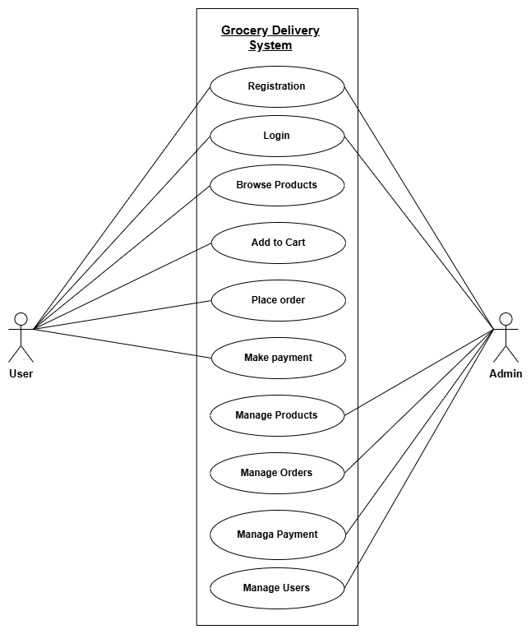
Fig 1 : Use Case Diagram of Grocery Delivery System
- Non-Functional Requirement
Non-functional requirements define how the system operates rather than what it does. They focus on the quality attributes of the system. The non-functional requirements for the Grocery Delivery System include:
- Effectiveness:
The system must effectively support grocery ordering and delivery by allowing customers to browse and purchase products easily, vendors to manage inventory efficiently.
- Usability:
The interface must be simple and intuitive so that customers and admins can use the system without special training.
- Productivity:
The system must streamline ordering, inventory management, and delivery assignment processes to reduce manual work for admins.
- Reliability:
The system must ensure accurate storage of user data, product inventory, orders, and delivery status, with proper error handling to prevent data loss or inconsistency.

3.1.2. Feasibility Study
The feasibility study determines the practicality of implementing the Grocery Delivery System by analyzing different aspects such as operations, technology, costs, and timelines.
i. Technical Feasibility
The Grocery Delivery System is technically feasible because all required technologies are readily available and affordable. The system can be built using open-source web technologies such as HTML, CSS, JavaScript, PHP and MySQL. These tools are widely supported, have extensive online documentation, and do not require specialized hardware, making development accessible even with limited resources.
ii. Operational Feasibility
The system is operationally feasible because it is designed to be user-friendly and intuitive. Customers can easily browse products, place orders, and track deliveries. Vendors can manage inventory and orders without complex procedures, and delivery personnel can update delivery statuses efficiently. Minimal training is required, and the platform is suitable for use on both web and mobile devices.
iii. Economic Feasibility
The project is economically feasible as it leverages open-source software, eliminating licensing costs. Development and maintenance costs are low, while the system provides value by simplifying order management, delivery, and inventory tracking. Customers can use the system without purchasing additional software, making it cost-effective for all stakeholders.
iv. Schedule Feasibility
The system development is schedule feasible. By following a structured plan with clearly defined milestones for interface design, backend development, testing, and deployment, the Grocery Delivery System can be completed within the allotted timeframe.
Table 1: Gantt Chart
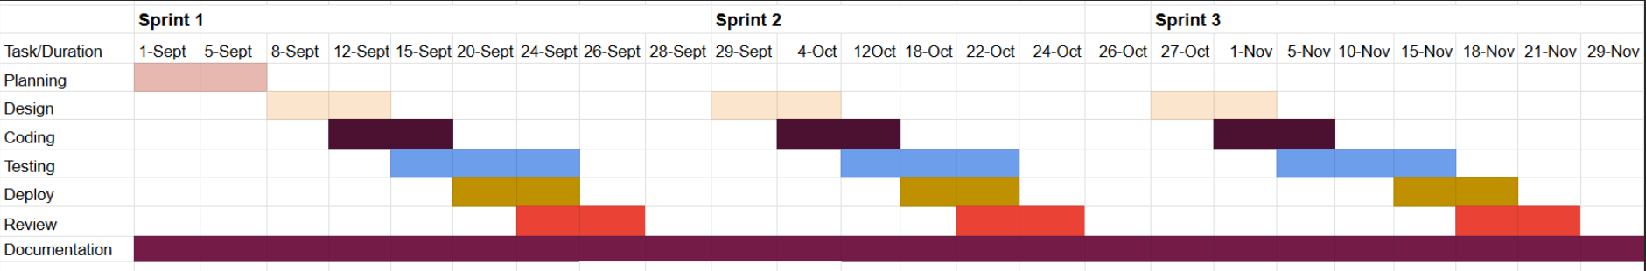
Fig 1.1: Gantt Chart of Grocery Delivery System

3.1.3. Data Modeling

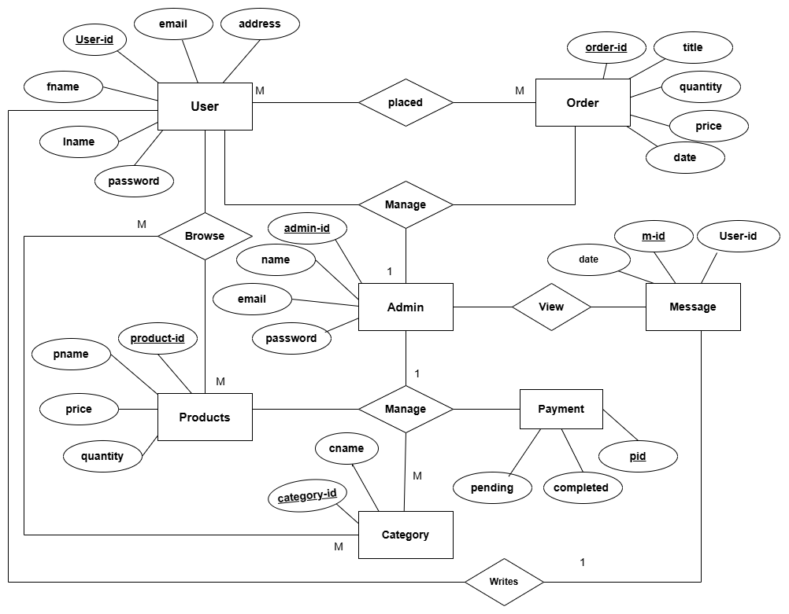
Fig 2: ER Diagram of Grocery Delivery System

3.1.4. Process Modeling
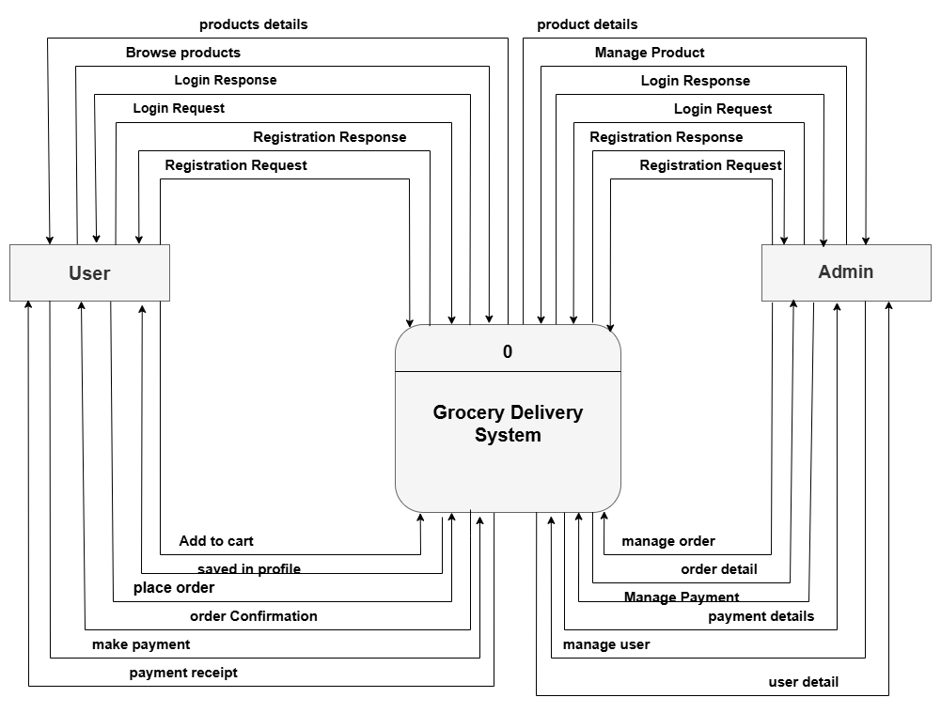

Fig 3: DFD Level 0 of Grocery Delivery System

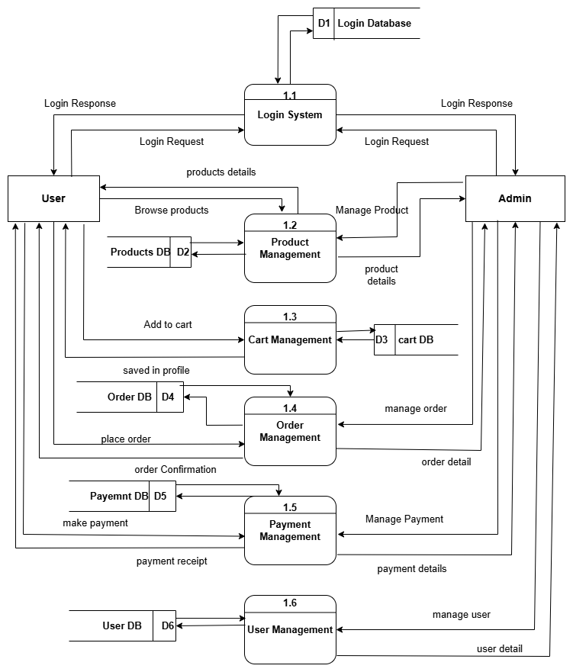
Fig 4: DFD Level 1 of Grocery Delivery System

3.2. System Design
System design is the process of defining the architecture, components, and functionality of a software system. It involves creating detailed specifications, diagrams, and plans that outline how the system will be built and function. The learning management system site is designed using various schema design, CASE tools and is described using following designs:

3.2.1. Architectural Design
Architectural design is the process of figuring out the different parts that make up a system and how these parts will work together. It involves determining how these parts will communicate and be controlled to create a well-organized and efficient system.
Architectural design ensures that all the pieces fit together seamlessly to create a reliable and effective system. It serves the foundation for the development and implementation of the software.
3-tier architecture has been adopted for this system.
- Presentation Layer (HTML, CSS, JavaScript)
This is the Presentation Layer of the system where users interact with the GDS. It is developed using HTML, CSS, JavaScript and provides features like login, Product browsing, and dashboards. It sends user requests to the backend and displays the responses in a user-friendly way.
- Application Layer (PHP)
This layer acts as the brain of the system. Built with PHP, it processes user requests, applies business logic, and handles authentication and validations. It communicates between the Presentation Layer and the Database.
- Database Layer (Backend)
This is the data storage layer of the Grocery Delivery System. It uses MySQL to store all important information such as user details, Products, and Orders. It responds to queries from the backend and ensures data is securely managed.
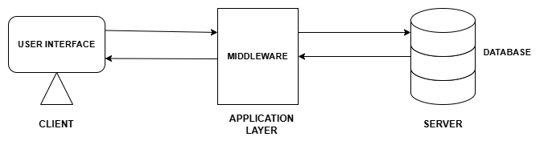

Fig 1.5: Architectural design of Grocery Delivery System

3.2.2. Database Schema Design
Database schema design organizes the data into separate entities, determines how to create relationships between organized entities, and how to apply the constraints on the data. In the figure below, there are tables in the database each of them has their own fields and identified with their respective primary key which when used in another table, becomes foreign key. The fields in each entity table have data type according to the data it stores.
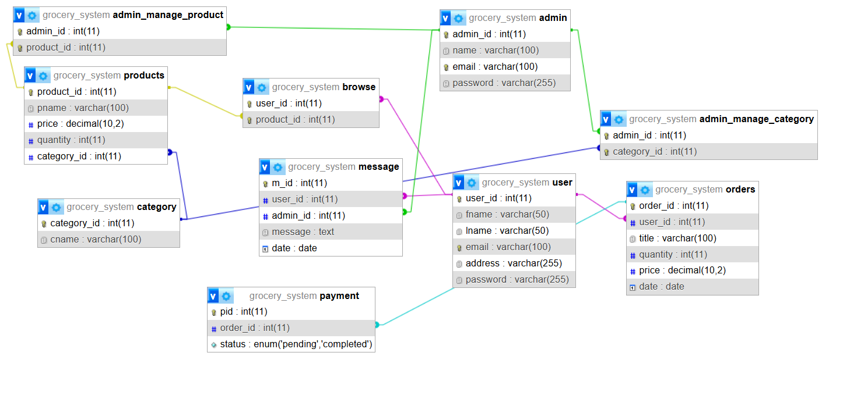
Fig 1.6: Database Schema Design of Grocery Delivery System

3.2.3. Interface Design
User interface is the front-end application view to which user interacts in order to use the software. It is used to build interfaces in system focusing on looks and styles. Here we tried to design user friendly interfaces so that users find easy to use and pleasurable. The following are the UI design of home page, login page, user dashboard, etc.
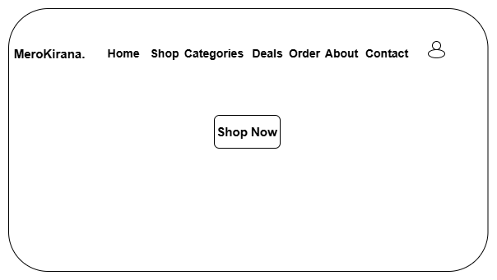
Fig 2: Home Page of Grocery Delivery System
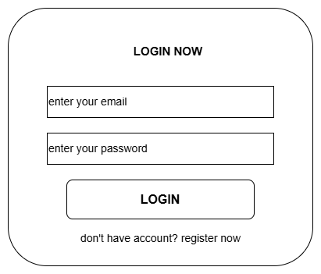
Fig 2.1: Sign in page of Grocery Delivery System

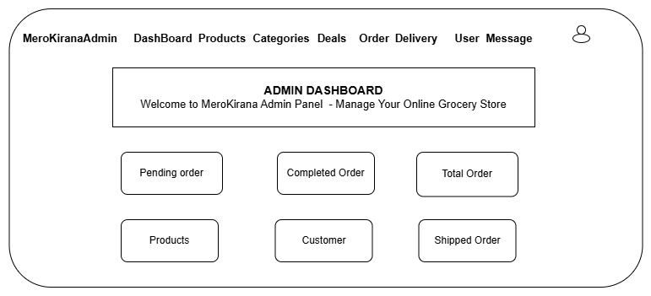
Fig 2.2: Admin Dashboard of Grocery Delivery System

3.3 High -Level Design

3.3.1 Methodology of the system
The development of the Grocery Delivery System follows the Agile Development Methodology, which is highly suitable for web-based applications that require flexibility, scalability, and continuous improvement. Agile methodology emphasizes iterative development, collaboration, and adaptability, ensuring that the final product meets both user and business needs effectively.
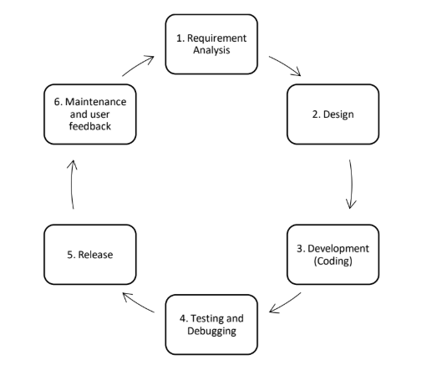

Fig 2.4: Agile Software Development Model
- Requirement Analysis: Collect and analyze the needs of users to define what the system should do.
- Design: Plan the system architecture, database, and user interface based on the requirements.
- Development (Coding): Write the code and implement the planned features.
- Testing and Debugging: Test the system to find and fix errors or issues.
- Release: Deploy the system for use by students, educators, and admin.
- Maintenance and User Feedback: Monitor the system, gather feedback, and make improvements for better performance and usability.

3.3.2 Algorithm Details
- Content-Based Recommendation Algorithm (CBRA)
The Content-Based Recommendation Algorithm is used to suggest grocery products to users based on their preferences and past interactions such as browsing history, purchase history, and product features.
The algorithm analyzes the similarity between user interests and product attributes to generate personalized recommendations.
Factors Considered
The recommendation is based on the following factors:
- User purchase history
- Browsing behavior
- Product category
- Price range
Mathematical Model
Let:
UUU = User profile vector
IjI_jIj​ = Feature vector of product jjj
S(U,Ij)S(U, I_j)S(U,Ij​) = Similarity between user and product
nnn = Total number of products
Similarity Function (Cosine Similarity)
The similarity between the user profile and product is calculated as:
S(U,Ij)=U⋅Ij∥U∥∥Ij∥S(U,I_j)=\frac{U\cdot I_j}{\|U\|\|I_j\|}S(U,Ij​)=∥U∥∥Ij​∥U⋅Ij​​
Where:
U⋅IjU \cdot I_jU⋅Ij​ = Dot product of vectors
∣U∣,∣Ij∣|U|, |I_j|∣U∣,∣Ij​∣ = Magnitudes of vectors
Higher similarity score → better recommendation
User Profile Construction
The user profile is generated as:
U=1k∑i=1kIiU = \frac{1}{k} \sum_{i=1}^{k} I_iU=k1​i=1∑k​Ii​
Where:
IiI_iIi​ = Feature vector of previously interacted products
kkk = Number of products interacted by user
Fitness Function (Recommendation Score)
Each product is evaluated using:
Scorej=S(U,Ij)Score_j = S(U, I_j)Scorej​=S(U,Ij​)
Higher score indicates a more relevant product for the user.
Algorithm Steps
- Initialize product feature vectors
- Collect user interaction data (purchases, views)
- Construct user profile vector UUU
- For each product IjI_jIj​:
- Compute similarity S(U,Ij)S(U, I_j)S(U,Ij​)
- Rank products based on similarity score
- Select top NNN products
- Output recommended products

Pseudo Code
Input: User data, Product dataset
Output: Recommended product list
Step 1: Extract features for all products
Step 2: Build user profile from past interactions
Step 3: For each product:
Compute similarity score
Step 4: Sort products in descending order
Step 5: Select top N products
Step 6: Return recommended products
Example (Grocery System)
User purchased:
- Apple
- Banana
User profile:
- Category: Fruits
- Tag: Fresh
Recommended products:
- Orange
- Mango
- Grapes

ii) FIFO (First In First Out) Algorithm
First item that comes in → first item that goes out
It works like a queue (line system) where:
- The oldest product/order is processed first
- The newest product/order is processed last
FIFO in Grocery Delivery System
1. Inventory Management (Warehouse)
- Suppose a store receives:
  - Milk batch A (Monday)
  - Milk batch B (Wednesday)
Using FIFO:
- Sell/deliver batch A first
- Then sell batch B
✔ This prevents expiry and waste
2. Order Processing
FIFO can also be used for handling customer orders:
Example:
- Order 1 → placed at 10:00 AM
- Order 2 → placed at 10:05 AM
- Order 3 → placed at 10:10 AM
Delivery system processes:
- First → Order 1
- Then → Order 2
- Then → Order 3
✔ Ensures fairness and timely delivery
3. Delivery Queue (Drivers)
- Orders are assigned to delivery drivers in FIFO order
- The earliest ready order is delivered first

CHAPTER 4: IMPLEMENTATION AND TESTING

4.1 Implementation
In this phase, the theoretical design of the Grocery Delivery System is transformed into a fully functional and working web application. This is one of the most important stages of system development, as it ensures that the designed solution operates efficiently under real-world conditions. The primary objective of this phase is to convert the system design into an operational platform that fulfills all specified functional and non-functional requirements.
During the implementation phase, all major modules of the system are developed and integrated. These include user authentication, product catalog management, shopping cart, order placement, payment processing, delivery tracking, and administrative dashboards. Each module is carefully coded and tested to ensure accuracy, performance, and usability. Prior to deployment, comprehensive testing is carried out to detect and correct errors related to functionality, security, and user interaction. This testing phase ensures that the system responds correctly to user inputs and performs reliably.
Only after successful testing and verification—confirming that the system meets all defined specifications—is the Grocery Delivery System prepared for actual use by customers, store administrators, and delivery personnel.
Tools Used
The following tools and technologies are used in designing and developing the Grocery Delivery System:
a. Front End: HTML, CSS, and JavaScript
HTML
HTML (HyperText Markup Language) is used to create the basic structure of the grocery delivery web application. It defines the layout of web pages and organizes content such as product listings, forms, buttons, and tables. HTML serves as the foundation of the system, ensuring structured and accessible content.

CSS
Cascading Style Sheets (CSS) are used to control the presentation and visual appearance of the system. CSS helps in designing responsive layouts, applying colors, fonts, spacing, and ensuring consistency across different devices and screen sizes. It enhances the overall user interface and user experience.
JavaScript
JavaScript is a high-level, interpreted programming language used to make the Grocery Delivery System interactive and dynamic. It handles client-side logic such as form validation, cart updates, user interactions, and communication with backend services. JavaScript enables smooth navigation and real-time updates without reloading pages.

b. Back End: PHP and MySQL
PHP
PHP (Hypertext Preprocessor) is a server-side scripting language used to develop the backend of the Grocery Delivery System. It handles user authentication, product management, order processing, payment handling, and communication with the database. PHP processes user requests, applies business logic, and returns appropriate responses to the frontend.
MySQL
Every web application requires a reliable database to store and manage data. MySQL, an open-source and widely used database management system, is used to store information such as user details, product inventory, orders, payments, and delivery records. MySQL ensures secure, structured, and efficient data storage and retrieval.
Diagram tools: Draw.io
Draw.io
Draw.io is a web-based diagramming tool used to design system architecture diagrams, data flow diagrams, and entity relationship diagrams (ER diagrams) for the Grocery Delivery System. It helps in visually representing system components and their interactions in a clear and structured manner.

4.2 Implementation Details of Modules
According to the demand, this website can be divided into several main functional modules. Basically, we have divided our project into three main functional modules.
They are:
- User Module
- Admin Module
Grocery Delivery System

User Module
Admin Module

Fig 2.5: Module Implementation of Grocery Delivery System

User Module
The customer module is designed to provide a smooth and convenient shopping experience for users. It allows customers to browse available products, add items to their cart, place orders, and track deliveries. Customers can register and log in to access system features, view order history, manage their profile, and make payments securely. This module focuses on delivering a user-friendly interface that ensures seamless shopping, timely delivery, and a satisfying customer experience.
<?php
@include 'config.php';
session_start();
$user_id = $_SESSION['user_id'] ?? null;
if(!isset($user_id)){
// Allow guest access to home page
}
if(isset($_POST['add_to_wishlist']) && isset($user_id)){
$pid = $_POST['pid'];
$pid = filter_var($pid, FILTER_SANITIZE_STRING);
$p_name = $_POST['p_name'];
$p_name = filter_var($p_name, FILTER_SANITIZE_STRING);
$p_price = $_POST['p_price'];
$p_price = filter_var($p_price, FILTER_SANITIZE_STRING);
$p_image = $_POST['p_image'];
$p_image = filter_var($p_image, FILTER_SANITIZE_STRING);
$check_wishlist_numbers = $conn->prepare("SELECT * FROM `wishlist` WHERE name = ? AND user_id = ?");
$check_wishlist_numbers->execute([$p_name, $user_id]);
$check_cart_numbers = $conn->prepare("SELECT * FROM `cart` WHERE name = ? AND user_id = ?");
$check_cart_numbers->execute([$p_name, $user_id]);
if($check_wishlist_numbers->rowCount() > 0){
$message[] = 'already added to wishlist!';
}elseif($check_cart_numbers->rowCount() > 0){
$message[] = 'already added to cart!';
}else{
$insert_wishlist = $conn->prepare("INSERT INTO `wishlist`(user_id, pid, name, price, image) VALUES(?,?,?,?,?)");
$insert_wishlist->execute([$user_id, $pid, $p_name, $p_price, $p_image]);
$message[] = 'added to wishlist!';
}
}
if(isset($_POST['add_to_cart']) && isset($user_id)){
$pid = $_POST['pid'];
$pid = filter_var($pid, FILTER_SANITIZE_STRING);
$p_name = $_POST['p_name'];
$p_name = filter_var($p_name, FILTER_SANITIZE_STRING);
$p_price = $_POST['p_price'];
$p_price = filter_var($p_price, FILTER_SANITIZE_STRING);
$p_image = $_POST['p_image'];
$p_image = filter_var($p_image, FILTER_SANITIZE_STRING);
$p_qty = $_POST['p_qty'];
$p_qty = filter_var($p_qty, FILTER_SANITIZE_STRING);
$check_cart_numbers = $conn->prepare("SELECT * FROM `cart` WHERE name = ? AND user_id = ?");
$check_cart_numbers->execute([$p_name, $user_id]);
if($check_cart_numbers->rowCount() > 0){
$message[] = 'already added to cart!';
}else{
$check_wishlist_numbers = $conn->prepare("SELECT * FROM `wishlist` WHERE name = ? AND user_id = ?");
$check_wishlist_numbers->execute([$p_name, $user_id]);
if($check_wishlist_numbers->rowCount() > 0){
$delete_wishlist = $conn->prepare("DELETE FROM `wishlist` WHERE name = ? AND user_id = ?");
$delete_wishlist->execute([$p_name, $user_id]);
}
$insert_cart = $conn->prepare("INSERT INTO `cart`(user_id, pid, name, price, quantity, image) VALUES(?,?,?,?,?,?)");
$insert_cart->execute([$user_id, $pid, $p_name, $p_price, $p_qty, $p_image]);
$message[] = 'added to cart!';
}
}
?>
<!DOCTYPE html>
<html lang="en">
<head>
<meta charset="UTF-8">
<meta http-equiv="X-UA-Compatible" content="IE=edge">
<meta name="viewport" content="width=device-width, initial-scale=1.0">
<title>home page</title>
<!-- font awesome cdn link -->
<link rel="stylesheet" href="https://cdnjs.cloudflare.com/ajax/libs/font-awesome/6.1.1/css/all.min.css">
<!-- custom css file link -->
<link rel="stylesheet" href="css/style.css">
<link rel="stylesheet" href="css/animations.css">
<link rel="stylesheet" href="css/merokirana.css">
<style>
.home-category .box-container {
grid-template-columns: repeat(4, 1fr);
gap: 1.5rem;
}
.home-category .box {
height: 35rem;
}
.see-more {
text-align: center;
margin-top: 2rem;
}
</style>
</head>
<body>
<?php include 'header.php'; ?>
<div class="home-bg">
<section class="home">
<div class="content">
<span>Fresh • Fast • Affordable</span>
<h3>Your Neighborhood Online Grocery Store</h3>
<p>Get fresh groceries, vegetables, fruits, and daily essentials delivered to your doorstep. Fast delivery, secure payments, and quality guaranteed.</p>
<div class="hero-buttons">
<a href="shop.php" class="btn">Shop Now</a>
</div>
</div>
</section>
</div>
<section class="home-category">
<h1 class="title">Shop by Category</h1>
<div class="box-container">
<?php
$select_categories = $conn->prepare("SELECT * FROM `categories` LIMIT 4");
$select_categories->execute();
if($select_categories->rowCount() > 0){
while($fetch_category = $select_categories->fetch(PDO::FETCH_ASSOC)){
?>
<div class="box">
<img src="uploaded_img/<?= $fetch_category['image']; ?>" alt="">
<h3><?= ucfirst($fetch_category['name']); ?></h3>
<p><?= $fetch_category['description']; ?></p>
<a href="category.php?category=<?= $fetch_category['name']; ?>" class="btn">Shop <?= ucfirst($fetch_category['name']); ?></a>
</div>
<?php
}
}else{
echo '<p class="empty">No categories available!</p>';
}
?>
</div>
<div class="see-more">
<a href="category_search.php" class="btn">See All Categories</a>
</div>
</section>
<section class="products">
<h1 class="title">Latest Products</h1>
<div class="box-container">
<?php
$select_products = $conn->prepare("SELECT * FROM `products` ORDER BY id DESC LIMIT 6");
$select_products->execute();
if($select_products->rowCount() > 0){
while($fetch_products = $select_products->fetch(PDO::FETCH_ASSOC)){
?>
<form action="" class="box" method="POST" onclick="window.location.href='view_page.php?pid=<?= $fetch_products['id']; ?>'">
<div class="price">रु<span><?= $fetch_products['price']; ?></span>/-</div>
<img src="uploaded_img/<?= $fetch_products['image']; ?>" alt="">
<div class="name"><?= $fetch_products['name']; ?></div>
<input type="hidden" name="pid" value="<?= $fetch_products['id']; ?>">
<input type="hidden" name="p_name" value="<?= $fetch_products['name']; ?>">
<input type="hidden" name="p_price" value="<?= $fetch_products['price']; ?>">
<input type="hidden" name="p_image" value="<?= $fetch_products['image']; ?>">
<input type="number" min="1" value="1" name="p_qty" class="qty" onclick="event.stopPropagation()">
<input type="submit" value="add to wishlist" class="option-btn" name="add_to_wishlist" onclick="event.stopPropagation()">
<input type="submit" value="add to cart" class="btn" name="add_to_cart" onclick="event.stopPropagation()">
</form>
<?php
}
}else{
echo '<p class="empty">no products added yet!</p>';
} ?>
</div>
</section>
<section class="features">
<div class="box-container">
<div class="box">
<i class="fas fa-shipping-fast"></i>
<h3>Fast Delivery</h3>
<p>Same day delivery within Kathmandu Valley</p>
</div>
<div class="box">
<i class="fas fa-shield-alt"></i>
<h3>Quality Assured</h3>
<p>100% fresh and quality guaranteed products</p>
</div>
<div class="box">
<i class="fas fa-credit-card"></i>
<h3>Secure Payment</h3>
<p>Multiple payment options including eSewa, Khalti</p>
</div>
<div class="box">
<i class="fas fa-headset"></i>
<h3>24/7 Support</h3>
<p>Customer support available round the clock</p>
</div>
</div>
</section>
<div class="quick-actions">
<a href="cart.php" class="action-btn" title="View Cart">
<i class="fas fa-shopping-cart"></i> </a>
<a href="deals.php" class="action-btn" title="Hot Deals">
<i class="fas fa-fire"></i></a>
<a href="search_page.php" class="action-btn" title="Search">
<i class="fas fa-search"></i></a>
</div>
<?php include 'footer.php'; ?>
<script src="js/script.js"></script>
</body>
</html>
Admin Module
The admin module is responsible for managing and controlling the overall grocery delivery system operations. Administrators have the authority to add, update, or remove products, manage customer accounts, and monitor order processing. They can also oversee delivery schedules, assign delivery personnel, handle feedback, track system performance, and update operational settings as needed. This module ensures smooth functioning, data integrity, and efficient administration of the grocery delivery service.
<?php
@include 'config.php';
session_start();
$admin_id = $_SESSION['admin_id'];
if(!isset($admin_id)){
header('location:login.php');
}
?>
<!DOCTYPE html>
<html lang="en">
<head>
<meta charset="UTF-8">
<meta http-equiv="X-UA-Compatible" content="IE=edge">
<meta name="viewport" content="width=device-width, initial-scale=1.0">
<title>MeroKirana Admin Dashboard</title>
<!-- font awesome cdn link -->
<link rel="stylesheet" href="https://cdnjs.cloudflare.com/ajax/libs/font awesome/6.1.1/css/all.min.css">
<!-- custom css file link -->
<link rel="stylesheet" href="css/admin_style.css">
<link rel="stylesheet" href="css/merokirana.css">
<link rel="stylesheet" href="css/admin_modern.css">
</head>
<body>

<?php include 'admin_header.php'; ?>
<section class="dashboard">
<div class="admin-welcome">
<h1 class="title"><i class="fas fa-tachometer-alt"></i> Admin Dashboard</h1>
<p>Welcome to MeroKirana Admin Panel - Manage your online grocery store</p>
</div>
<div class="box-container">
<div class="box stats-card">
<?php
$total_pendings = 0;
$select_pendings = $conn->prepare("SELECT * FROM `orders` WHERE payment_status = ?");
$select_pendings->execute(['pending']);
while($fetch_pendings = $select_pendings->fetch(PDO::FETCH_ASSOC)){
$total_pendings += $fetch_pendings['total_price'];
};
?>
<div class="stat-icon pending"><i class="fas fa-clock"></i></div>
<h3>रु<?= $total_pendings; ?>/-</h3>
<p>Pending Orders</p>
<a href="admin_orders.php" class="btn">View Orders</a>
</div>
<div class="box stats-card">
<?php
$total_completed = 0;
$select_completed = $conn->prepare("SELECT * FROM `orders` WHERE payment_status = ?");
$select_completed->execute(['completed']);
while($fetch_completed = $select_completed->fetch(PDO::FETCH_ASSOC)){
$total_completed += $fetch_completed['total_price'];
};
?>
<div class="stat-icon completed"><i class="fas fa-check-circle"></i></div>
<h3>रु<?= $total_completed; ?>/-</h3>
<p>Completed Orders</p>
<a href="admin_orders.php" class="btn">View Orders</a>
</div>
<div class="box stats-card">
<?php
$select_orders = $conn->prepare("SELECT * FROM `orders`");
$select_orders->execute();
$number_of_orders = $select_orders->rowCount();
?>
<div class="stat-icon orders"><i class="fas fa-shopping-bag"></i></div>
<h3><?= $number_of_orders; ?></h3>
<p>Total Orders</p>
<a href="admin_orders.php" class="btn">Manage Orders</a>
</div>
<div class="box stats-card">
<?php
$select_products = $conn->prepare("SELECT * FROM `products`");
$select_products->execute();
$number_of_products = $select_products->rowCount();
?>
<div class="stat-icon products"><i class="fas fa-box"></i></div>
<h3><?= $number_of_products; ?></h3>
<p>Products</p>
<a href="admin_products.php" class="btn">Manage Products</a>
</div>
<div class="box stats-card">
<?php
$select_users = $conn->prepare("SELECT * FROM `users` WHERE user_type = ?");
$select_users->execute(['user']);
$number_of_users = $select_users->rowCount();
?>
<div class="stat-icon users"><i class="fas fa-users"></i></div>
<h3><?= $number_of_users; ?></h3>
<p>Customers</p>
<a href="admin_users.php" class="btn">View Customers</a>
</div>
<div class="box stats-card">
<?php
$select_shipped = $conn->prepare("SELECT * FROM `orders` WHERE delivery_status = ?");
$select_shipped->execute(['shipped']);
$number_of_shipped = $select_shipped->rowCount();
?>
<div class="stat-icon shipped"><i class="fas fa-truck"></i></div>
<h3><?= $number_of_shipped; ?></h3>
<p>Shipped Orders</p>
<a href="admin_orders.php" class="btn">Track Orders</a>
</div>
</div>
</section>
<section class="quick-actions-admin">
<div class="action-card">
<i class="fas fa-plus-circle"></i>
<h3>Add Product</h3>
<p>Add new products to your inventory</p>
<a href="admin_products.php" class="btn">Add Product</a>
</div>
<div class="action-card">
<i class="fas fa-chart-line"></i>
<h3>Sales Report</h3>
<p>View detailed sales analytics</p>
<a href="admin_orders.php" class="btn">View Report</a>
</div>
<div class="action-card">
<i class="fas fa-cog"></i>
<h3>Settings</h3>
<p>Manage store settings and preferences</p>
<a href="admin_update_profile.php" class="btn">Settings</a>
</div>
</section>
<script src="js/script.js"></script>
</body>
</html>

4.3. Testing
Testing is a process of executing a program with the intent of finding an error. It is the process of trying something to see if it works as expected. The primary objective for test case design is to derive a set of tests that has the highest livelihood for uncovering defects in software.
To accomplish this objective two different categories of test case design are used.

4.3.1. Test Case for Unit Testing
Unit testing emphasizes the verification effort on the smallest unit of software design i.e., a software component or module. Unit testing is performed parallel with the coding phase. It tests unit or module not the whole software. We have tested each view/module of the applications individually. As the modules were built up testing was carried out simultaneously, tracking out each and every kind of input and checking the corresponding output until module is working correctly.
Table 2: User Registration Testing
Test ID | Test Scenario | Test Input |  |  |  |  | Expected output | Actual Output | Status
 |  | Name | Email | Password | Cpassword | File
T1 | Sign-in | Goma Magar | goma12@  gmail.com | goma@123 | goma@123 | Screenshot 2025-09-08 155228 | Registered successfully | Pass | Success
T2 | Sign-in | Anu Tamang | anu12@gmail.com | anu@123 | anu@123 | No File Choosen | Registered Successfully | Pass | Success

Table 3: User Login testing
Test ID | Test Scenario | Test Input |  | Expected Output | Actual Output | Status
 |  | Email | Password
T3 | Login | goma12@  gmail.com | goma@123 | Login Successfully | Pass | Success
T4 | Login | anu12@gmail | anu@123 | Login Successfully | Pass | Success

Table 4: Admin Registration Testing
Test ID | Test Scenario | Test Input |  |  |  |  | Expected output | Actual Output | Status
 |  | Name | Email | Password | Cpassword | File
T5 | Sign-in | Goma magar | Adminaccount12@gmail.com | adminaccount12 | Adminaccount12 | Screenshot 2025-09-08 155228 | Registered successfully | Pass | Success

Table 5: Admin Login testing
Test ID | Test Scenario | Test Input |  | Expected Output | Actual Output | Status
 |  | Email | Password
T6 | Login | Adminaccount12@gmail.com | adminaccount12 | Login Successfully | Pass | Success

Table 6: Product adding Testing
Test ID | Test Scenario | Test Steps | Test data | File | Expected  Output | Status
T7 | Add Product | Go to the Product and click in add details | Fill every Product in details | Add Product Image | Product added  successfully | Success

Table 7: Category adding Testing
Test ID | Test Scenario | Test Steps | Test data | File | Expected  Output | Status
T8 | Add Category | Go to the Category and click in add details | Fill Category in details | Add Category Image | Category added  successfully | Success

4.5 Test Cases for System Testing
System testing tests the integration of each module in the system. We have tested whether the entire system is working properly or not. Different verifications and validations are done by giving input values to the system and by comparing with expected output.
Table 8: System testing of Grocery Delivery System
Test id | Test Scenario | Test data | Expected result | Actual Result | Status
T1 | Sign-in | Name, Email, Password, Cpassword, File | Registered Successfully | Pass | Success
T3 | Login | Email, Password | Login Successfully | Pass | Success
T5 | Sign-in | Name, Email, Password, Cpassword, File | Registered Successfully | Pass | Success
T6 | Login | Email, Password | Login Successfully | Pass | Success
T7 | Add Product | Name, Detail, File | Product added successfully | Pass | Success
T8 | Add Category | Name, Detail, File | Category added successfully | Pass | Success

CHAPTER 5: CONCLUSION AND RECOMMENDATION

5.1. Lessons Learned / Outcomes
- Responsive Frontend Development: Learned HTML, CSS, JavaScript to build a user-friendly interface for customers, delivery staff, and admin, ensuring smooth experience on desktop and mobile.
- Robust Backend Integration: Gained practical experience with PHP and RESTful APIs to handle authentication, order processing, inventory management, and payment securely.
- Efficient Order & Delivery Management: Implemented features for real-time order tracking, delivery assignment, and notifications, improving system reliability.
- Secure Role-Based Access: Applied JWT authentication to ensure customers, delivery staff, and admins access only authorized features.
- Modular System Architecture: Designed a layered system separating frontend, business logic, and database, improving scalability and maintainability.
- Production-Ready Platform: Delivered a fully functional Grocery Delivery System demonstrating modern web development practices.

5.2. Conclusion
The Grocery Delivery System project has been successfully developed as a web-based platform to simplify and modernize grocery shopping and delivery services. The primary objective of the project was to provide a convenient, reliable, and user-friendly system that allows customers to order groceries online while enabling administrators to manage inventory, orders, and deliveries efficiently. These objectives have been successfully achieved.
The use of modern frontend technologies such as React.js, along with backend tools like PHP and MySQL, has resulted in a responsive, secure, and reliable application. The system offers essential features such as product browsing, online ordering, order tracking, and administrative control through dashboards, ensuring smooth interaction for all users.
In conclusion, the integration of frontend and backend technologies has produced an efficient and scalable Grocery Delivery System. The system fulfills its intended purpose by improving customer convenience, reducing manual effort for store owners, and enhancing overall service quality.

5.3. Future Recommendation
The Grocery Delivery System has been developed with a flexible and modular design, allowing it to adapt to future requirements and scale as the business grows. To enhance its functionality and improve user experience, the following future developments are recommended:
- AI-Powered Product Recommendations
Implementing artificial intelligence and machine learning algorithms can help provide personalized product suggestions for customers. By analyzing user behavior, past purchases, and preferences, the system can offer smarter recommendations, increasing customer satisfaction and sales.

- Real-Time Order Tracking
Integrating live GPS tracking and real-time notifications for deliveries can enhance transparency and trust. Customers can monitor their orders, estimate delivery times, and receive alerts for delays or successful deliveries.

- Expanded Payment Options
Supporting multiple payment gateways, including digital wallets, UPI, and contactless payments, will improve convenience for users and attract a wider customer base.

- Automated Inventory Management
Introducing predictive inventory management using analytics can optimize stock levels, reduce shortages, and minimize wastage. This will ensure products are always available for customers.

- Live Customer Support and Chatbots
Adding AI-powered chatbots or live support features can provide immediate assistance for order-related queries, complaints, and feedback. This will enhance the overall customer experience and strengthen service reliability.

REFERENCE
[1] Banerjee, P., & Choudhury, S. (2020). Inventory and substitution management in online grocery systems. International Journal of Retail Management, 11(3), 65–80.
[2] E. S. L. N. N. S. F. A. Sai Babu, "SUPERMARKET BILLING SYSTEM USING WEBCAM," International Journal for Research in Applied Science & Engineering Technology , vol. 10, no. 9, pp. 1-3, 2022.
[3] Gupta, R., & Singh, A. (2021). Adoption of online grocery shopping in urban areas: Trends and challenges. International Journal of E-Commerce Studies, 12(3), 45–58.
[4] E. E. O. M. L. A. F.-D. J. E. Awodele Oludele, "BARCODE GENERATING SHOPPING CART SYSTEM," International Journal of Advanced Computing, vol. 48, no. 1, 2015.
[5] Rai, P., & Rani, S. (2020). Usability and customer satisfaction in online grocery platforms. Journal of Retail Technology, 8(2), 102–115.
[6] Sharma, V., Mehta, R., & Kapoor, S. (2019). Optimizing logistics in online grocery delivery systems. International Journal of Supply Chain Management, 7(1), 25–34.
[7] L. A.R. Jaya Sudha, "QR CODE BASED GROCERY DELIVERY WITH EXPIRYALERT SYSTEM," International Advanced Research Journal In Sciecne, Engineering and Technology, vol. 11, no. 6, pp. 1-6, 2024.

APPENDICES

Home page
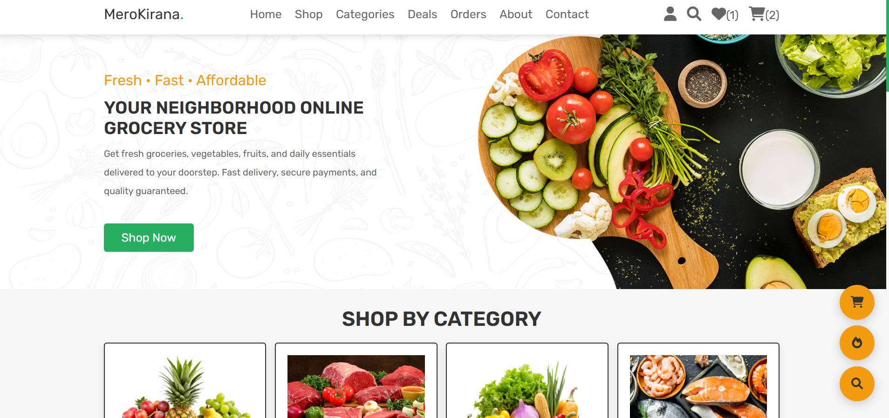

Login Page
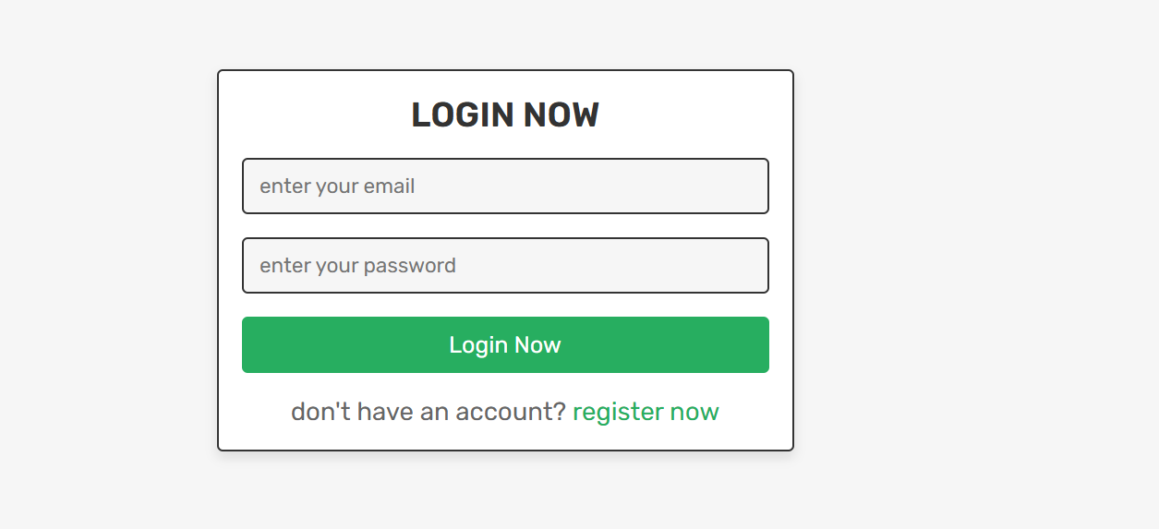

Registration page
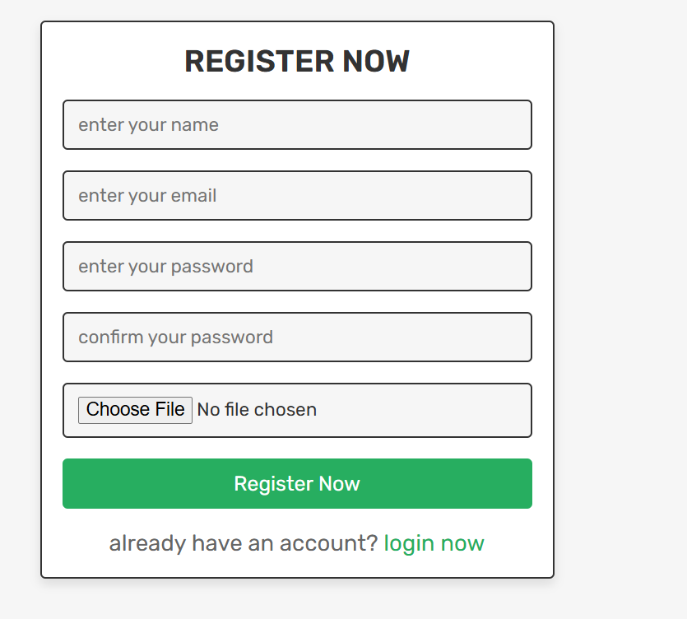

Deals Page

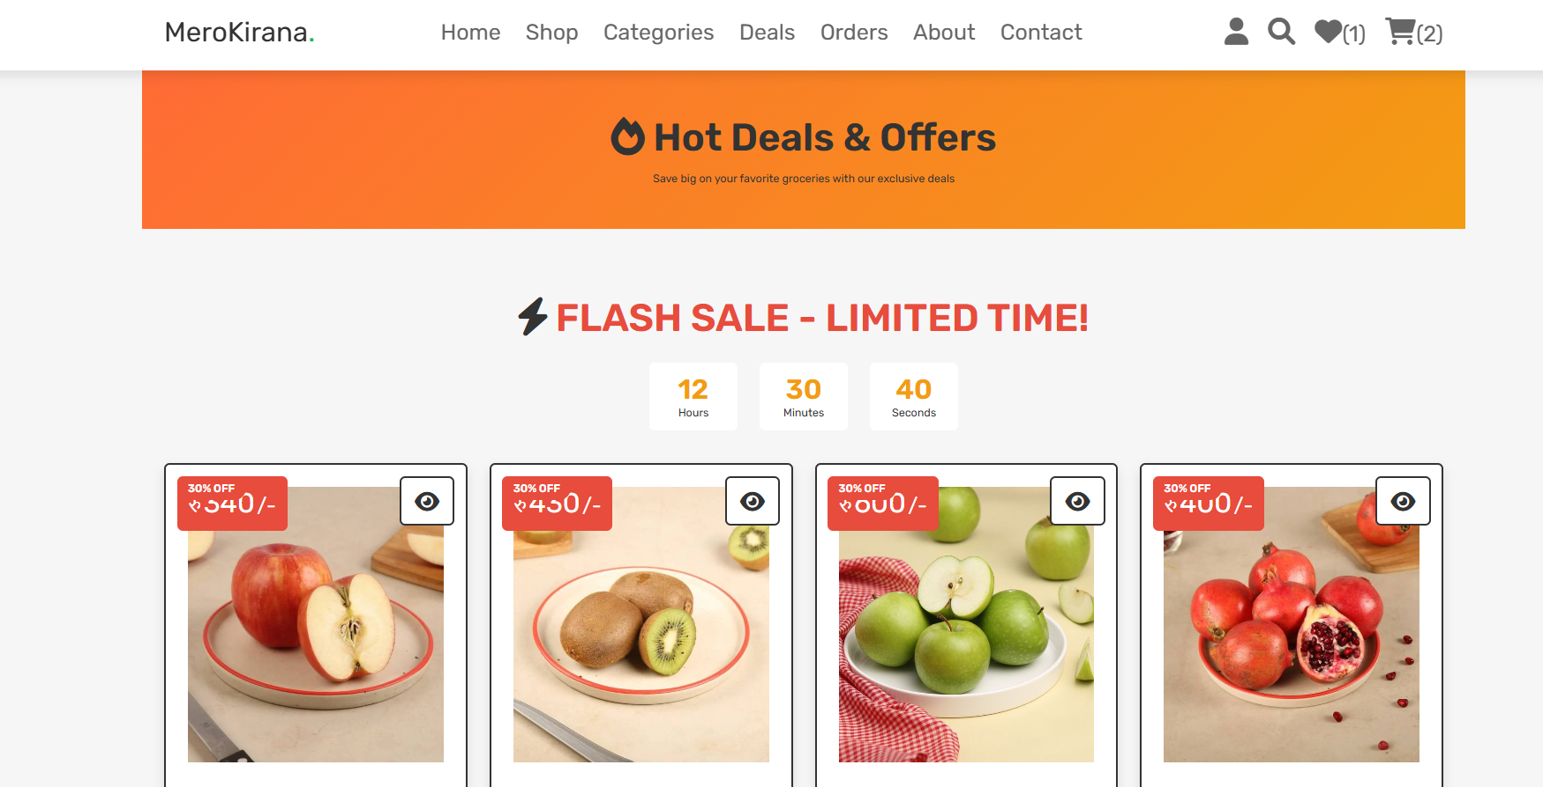

Admin Dashboard
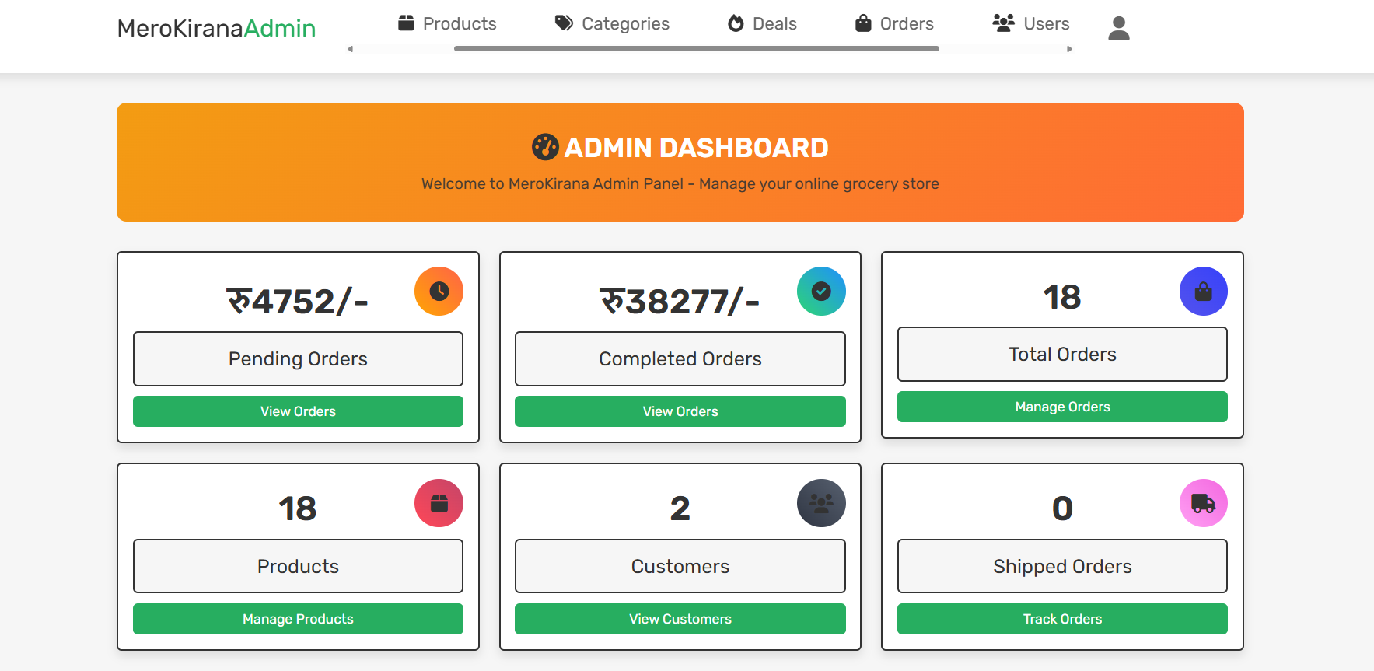

E-Sewa Payment Integration Page
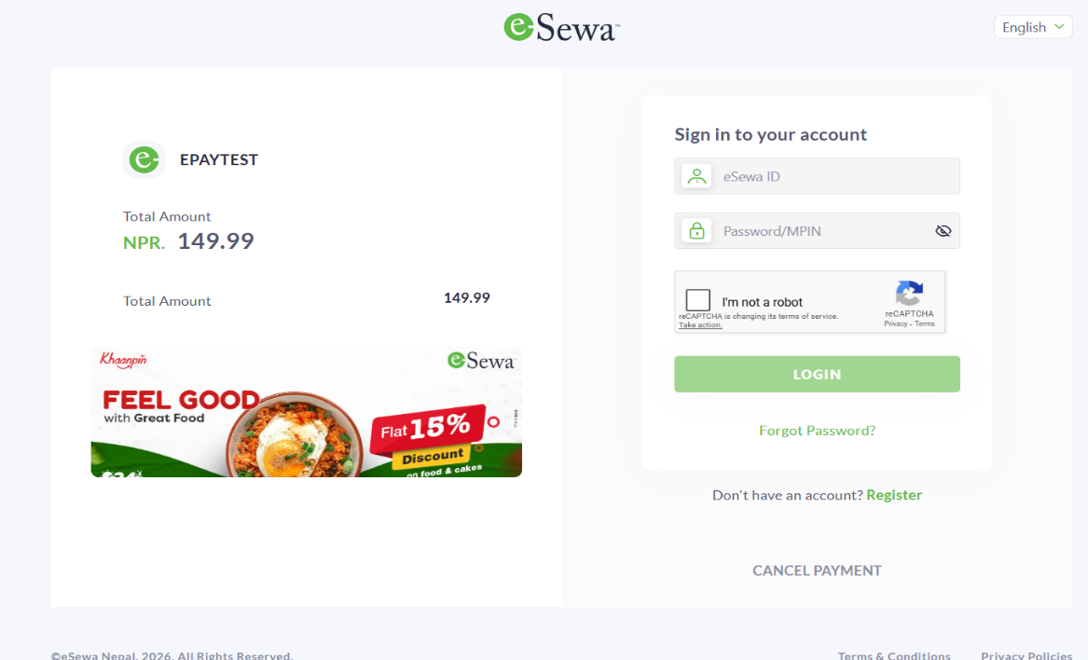

Product Adding Form

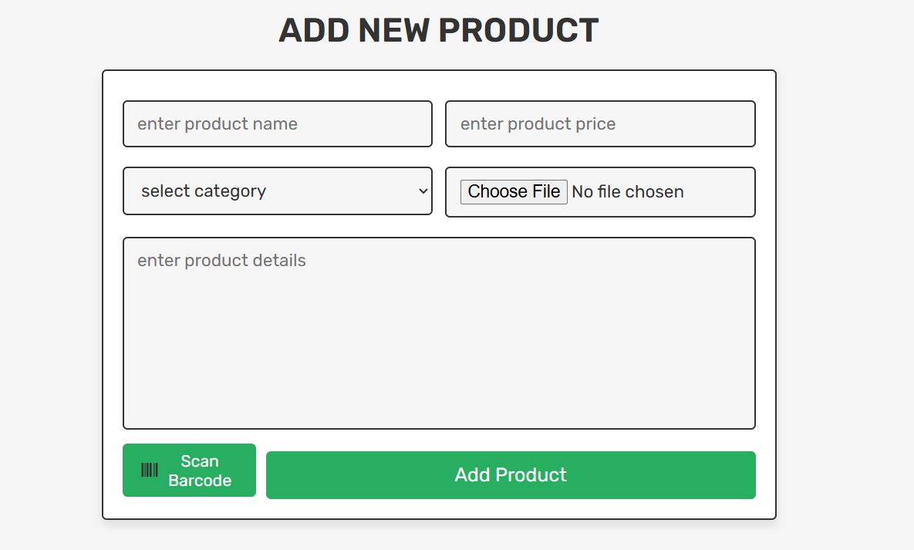

Category Adding Form
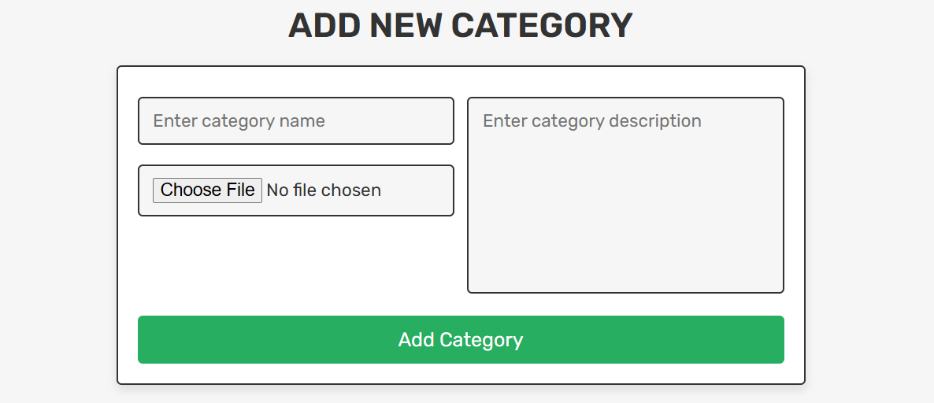

Admin User Management
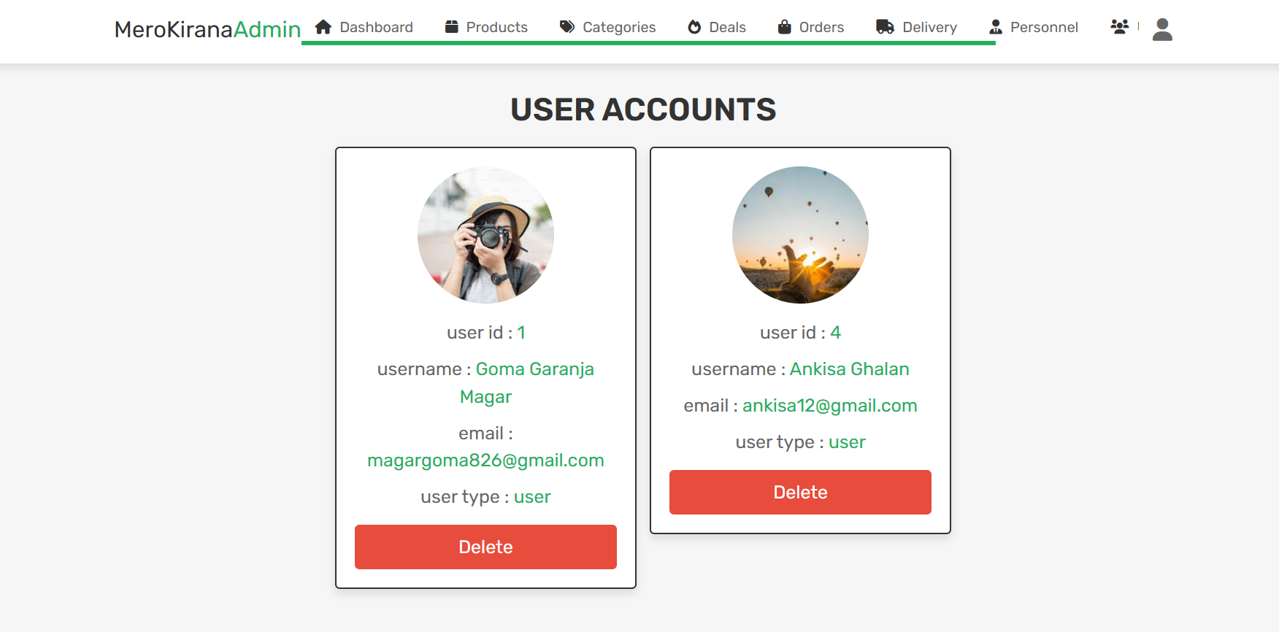

User Message (Admin side)
